**KAFKA PRODUCER (Async)  
  
Architecture Diagram**

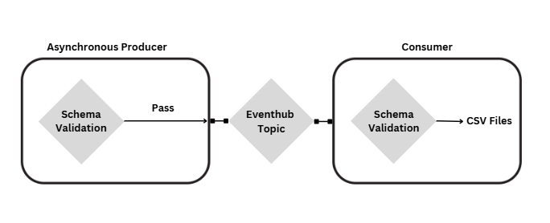 **Flow of Operation**

* **Configuration Loading**:
  + The system loads configurations from config.json, including credentials, Kafka topics, EventHub details, and connection parameters.
* **OAuth Authentication**:
  + Using eh_cert_oauth.py, the producer script authenticates with EventHub. This module leverages certificates for OAuth-based security, ensuring secure access to EventHub.
* **Data Production**:
  + The producer.py script generates or receives data to send to Kafka. The data is first validated via validate_schema.py, ensuring adherence to predefined schemas.
  + Once validated, producer.py uses Kafka’s asynchronous API to send data. Messages are queued for transmission, allowing for high throughput and minimal delays in data publishing.
* **Data Consumption**:
  + Consumer.py listens to the designated Kafka topic(s) and processes incoming messages as they arrive. It can perform various actions based on the message content, such as data transformation or forwarding to other systems.
* **Data Flow Validation**:
  + Throughout the process, validate_schema.py checks incoming and outgoing messages for consistency with predefined schemas. This validation step helps in detecting and handling malformed data early in the process.

**Usage Instructions**

**Running the Producer Module:**

1. Configure required parameters, including EventHub connection details and schema definitions.
2. Run the Producer script to initiate processing of files from local storage.

**Running the Consumer Module:**

1. Set up the necessary parameters, including EventHub connection details.
2. Execute the Consumer script to begin reading data from EventHub and writing it to CSV files.